https://forge.tcsbank.ru/case/5281010/info
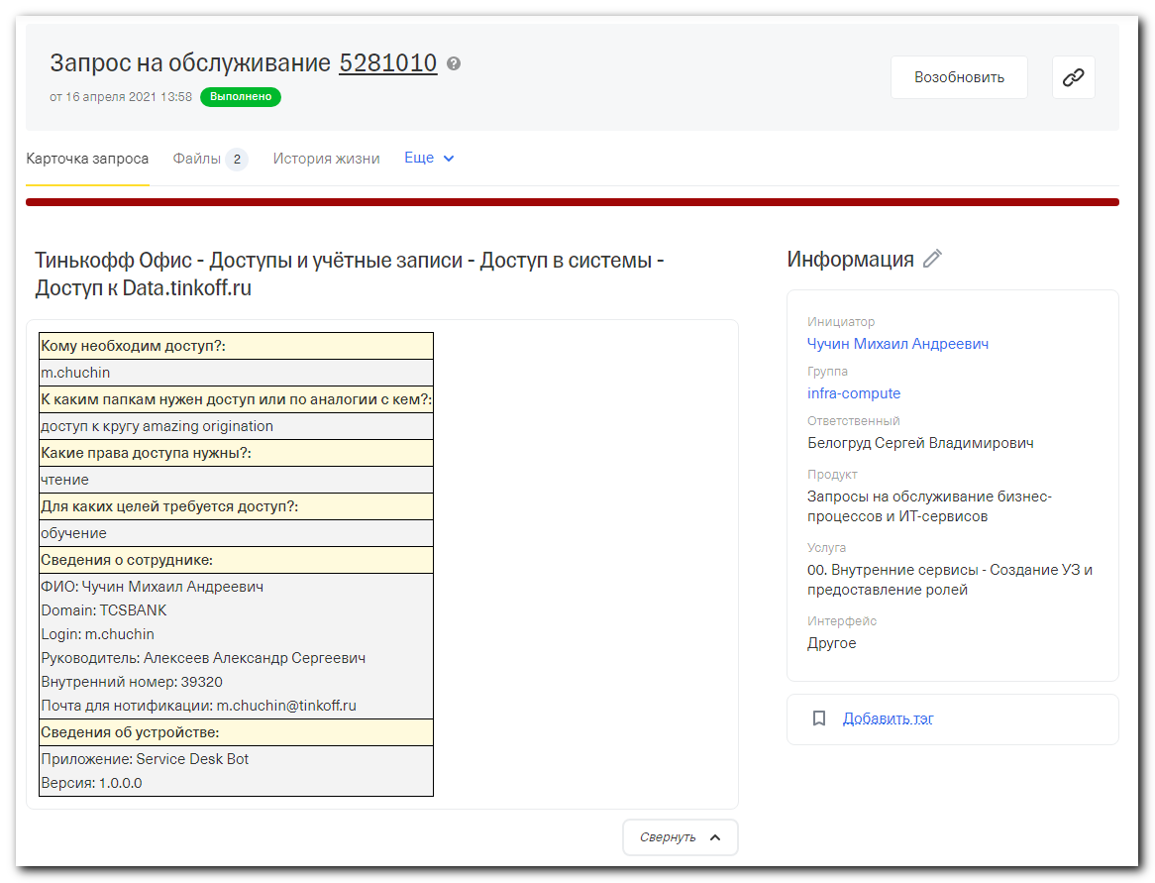
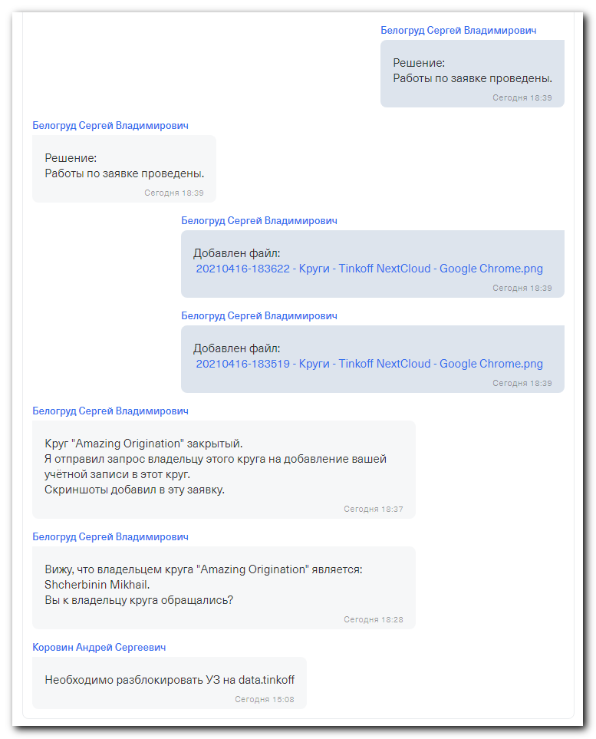

#
# User m.chuchin was blocked.
# I unblock him.

# Then, I found the circle "Amazing Origination", I found who was owner of this circle. It was "Shcherbinin Mikhail".
# I become as the user m.chuchin and did request to acquire into this circle. At the right conner appeared approriate record.
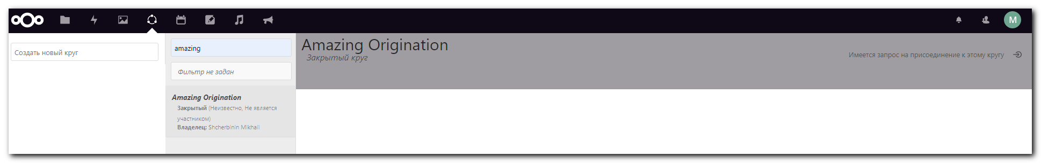

# I become as user "Shcherbinin Mikhail" (owner of the circle).
# Then, I went to the circle and found there request from m.chuchin.
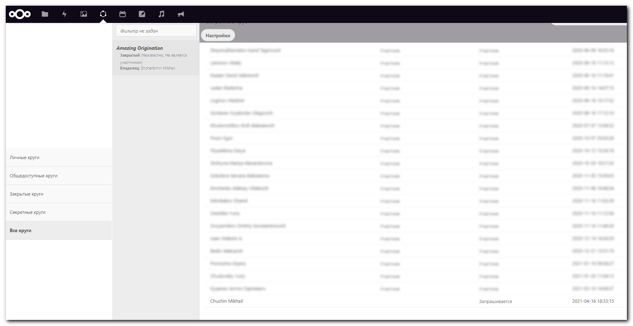

# I pressed special sign to add user into this circle. Then in the empty field I wrote m.chuchin and add him into the circle.
